Distance Teaching and Learning Policy

This Distance Learning Policy has been developed to reflect the changed circumstances in learning in our school brought about by Covid-19 and the significant increase in the use of technology to continue the high standard of teaching & learning in St. John’s NS. The aim of this policy is to provide guidelines and information to students, parents, and staff, surrounding the use of technology when learning remotely (i.e. from a place other than school where it is not possible for the teacher to deliver the class within the same location, as would be the case, if the class was taking place in a classroom setting.) This new policy operates alongside all our existing policies. This policy does not set out to replace our Acceptable Usage Policy but rather intends to be an important addition for the area of learning from a digital platform. The policy should also be read concurrently with our school’s Code of Behaviour and Anti-Bullying Policy.

Introduction
This document sets out the policy of the school in respect of use of technology for distance or remote teaching and learning and it operates in addition to our existing IT Acceptable Use Policy (AUP).

Scope of this Policy
In all cases students must use their @carramorens.ie account to log in to the recommended digital platforms. Students are not to use any other account under any circumstances for the purposes of distance learning within the school. The list of recommended applications that are used in St. John’s NS for distance learning are:
- Google classroom
- Google Meet and Zoom for live online classes
- Spellingsforme.ie
- Nessy.co.uk
- Ixl.com
- app.pmecollection.com.au
There may be some additional applications that teachers use, and the teacher will provide the student with the information required to access them.

Guidelines for good online communication:

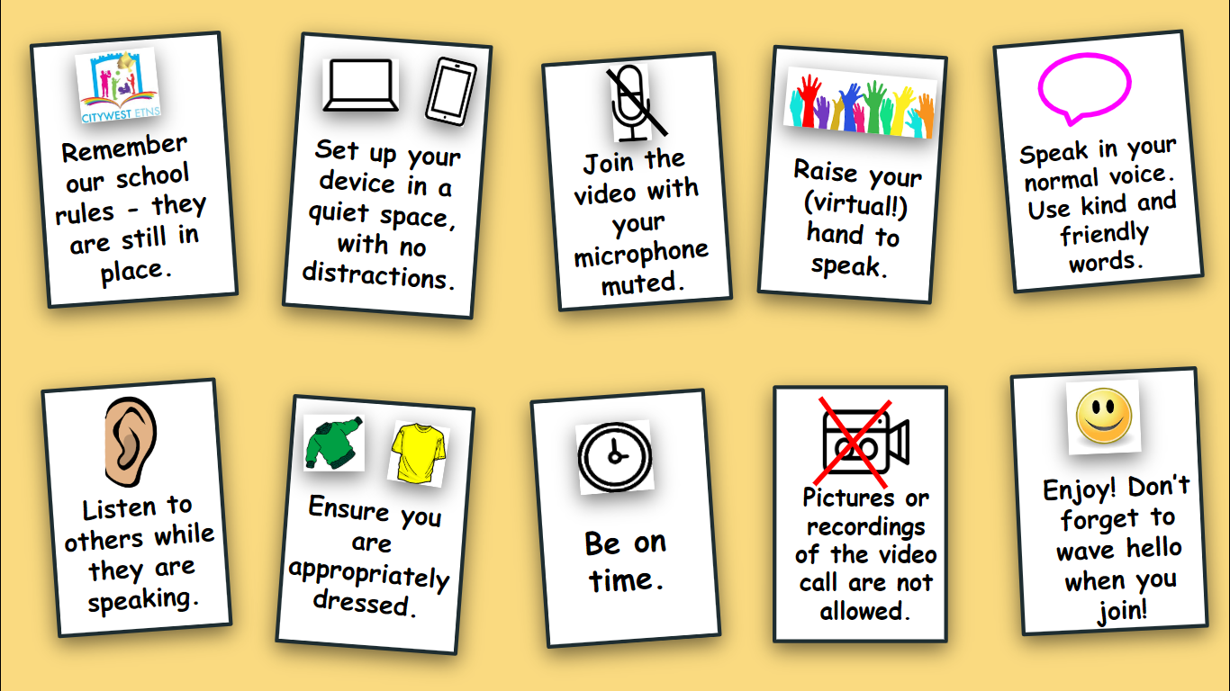

- Under no circumstances can pictures or recordings be taken of video calls.
- Staff, families and students are expected to behave in an appropriate, safe, respectful and kind manner online.
- It is the duty of parents/guardians to supervise children while they are working online and to ensure any content which they are submitting to their teacher is appropriate.
- Staff members can communicate with pupils and their families via google classroom, email, text and phone calls(school mobile).
- Any electronic forms of communication will be for educational purposes and to allow for communication with families.
- For video/Zoom calls, parental permission is implied.
Essentially, by virtue of the pupil logging on to the call, permission is assumed.
- For security reasons, passwords will be provided to all children.
- St. John’s NS cannot accept responsibility for the security of online platforms, in the event that they are hacked.
For video calls/Zoom:
- Remember our school rules - they are still in place, even online.
- Set up your device in a quiet space, with no distractions in the background.
- Pictures or recordings of the video call are not allowed.
- Speak in your normal voice, using kind and friendly words.
- Show respect by listening to others while they are speaking.
- Ensure that you are dressed appropriately for the video call.
- Be on time.

Guidelines for parents and guardians:
- It is the responsibility of parents/guardians to ensure any school devices on loan to their children are treated carefully.
- Any damage to school devices must be paid for by parents/guardians.
- It is the responsibility of parents and guardians to ensure that pupils are supervised while they work online.
- Check over the work which pupils send to their teacher, ensuring it is appropriate.
- Continue to revise online safety measures with pupils.

